Book Drive Tool Kit

Thank you for supporting Indy Book Project! Book drives are an important piece of our mission. Without your help, we couldn’t provide books to the children we serve. We created this tool kit to help guide you through the process of holding a book drive. It includes step-by-step instructions, helpful tips, book drive flyers, additional promotional content, and an FAQ section. If you have any questions, please contact us. We are here to help!

Table of Contents
Contact Information 2
10 Steps for Executing a Successful Book Drive 3
Book Drive Frequently Asked Questions (FAQs) 7
Book Drive Promotional Materials 8

Contact Information

Indy Book Project is a nonprofit organization dedicated to ensuring all children in Central Indiana have access to books. We are always looking for new and gently used books for kids ages 0-18.

https://www.indybookproject.org

1537 West Oak Street, Zionsville, IN 46077
indybookproject@gmail.com
317.344.9817

10 Steps for Executing a Successful Book Drive

Step 1: Identify a Location
Where do you want to host your book drive? Schools, businesses, churches, and community organizations are all great locations for a book drive. They can engage the entire community, give students a way to fulfill community service obligations, and allow families to repurpose gently used books that older children have outgrown.

Schools, especially elementary schools, are among the most important locations for book drives. Principals, teachers, community outreach directors, and librarians will usually support and help execute these events. As a first step, set up a meeting to discuss your idea and get permission from the school. (Note: We’ve included a sample proposal email in the promotional materials section of this kit.).

You can also consider using a special event—such as a holiday party or baby shower—for a drive. Books can be donated for entrance into the event, in place of exchanging gifts, or as a token of appreciation for a host. This is a fun way to get creative with a book drive.

Step 2: Recruit Help
What help will you need to run your book drive? Identify a few individuals who can serve as your book drive team (e.g., students, parents, teachers, community leaders, etc.). There is strength in numbers! The more people you have supporting and promoting the drive, the more books you’ll likely get donated.

Step 3: Choose Start and End Dates
Book drives typically run for one or two weeks and can be held any time of year. In fact, we love for book donations to come in throughout the year. Our goal is to have steady donations and distributions so we don’t face stockpiles or shortages.

Consider hosting a drive that coordinates with other events or monthly holidays that focus on books, reading, or literacy. Here are some examples: World Read Aloud Day (Feb.), Library Lovers Day/Month (Feb.), Read Across America Day (March), D.E.A.R. Day (April), National Library Week (April), Children’s Book Week (May), Get Caught Reading Month (May), Screen Free Week (May), Read a Book Day (Sept.), National Book Month (Oct.), Children’s Book Week (Nov.), National Family Literacy Day/Month (Nov.).

Please reach out to us to discuss a good date for your drive, along with the number and age range of the books you expect to be donated. We maintain a monthly calendar of drives to ensure we can help support your needs and the needs of the community.

Step 4: Identify Incentives
Providing incentives can make your book drive more appealing and fun. But offering an incentive may affect how you collect and count your books, so it’s a good idea to determine this up front. A contest is always a popular incentive choice. If you’re running a book drive at a school, consider offering a pizza party or extra recess for the class or grade that brings in the most books. You could also offer everyone a special surprise if you exceed a certain book donation goal.

Step 5: Determine a Collection Process
To ensure your book drive is successful, you’ll need to determine what type of container you’ll use for collection, where you’ll place the container(s), and who will count donations.

Boxes, bins, or cloth bags work best for collecting books. They are stronger, sturdier, and easier to transport than paper/plastic bags or piles. Smaller boxes work best since larger boxes get heavy quickly when filled with books. Consider asking your book drive team to begin collecting boxes prior to a large drive. Your school, business, or community organization may be able to help with this as well. You can also purchase boxes for $1-2 at hardware stores. If you need additional help with boxes, reach out to Indy Book Project—we may have some that you can use.

Placement of your container(s) may depend on the size of your drive and whether you need to count books in a special way for a contest or incentive. It’s often best to place collection bins in visible and safe locations inside of entrances or lobbies. If you’re counting books for a contest by classroom or grade, consider placing bins in classrooms or grade-level hallways.

Before the drive starts, identify who is responsible for counting and tracking all donations. This is necessary if you’re running a contest, but it’s also nice to share your final count with the students, colleagues, friends, family, and community members who donated books to your drive. A book count is also extremely helpful for Indy Book Project to plan for collection, storage, sorting, and distribution of books as they come in.

Step 6: Promote Your Drive
Promoting your book drive several weeks out will help people plan for it. Some may need time to sort through their books at home to identify which ones they’re willing to donate. Consider sending emails, distributing flyers, hanging marketing posters on main entry doors, sharing information over loudspeaker announcements or at community meetings, and/or promoting via social media.

You can make your own promotional materials or use the templates we’ve included in this kit. We can also customize our templates for your specific event, so reach out if we can help. If you make your own materials, be sure to include:
- Book drive dates and times
- Donation location and process
- Request for new or gently used books for ages 0-18
- Contact email and/or phone number for any questions
- Indy Book Project logo and website URL

Step 7: Run Your Drive
Have everything set up and ready to go before your drive. Hang flyers the week before, and place bins and review processes with anyone helping in the days leading up to your event. During the drive, be available for any questions. Take pictures as you go and post them on social media. You can also consider sharing book count numbers throughout the drive. Once your drive is over, remember to take down any flyers and remove remaining boxes and bins.

Step 8: Deliver Your Books
All donations need to make their way to the Indy Book Project office located at 1537 West Oak Street, Zionsville, IN 46077. For smaller book donations (<250 books), we ask that you drop off your books in a collection bin outside the office. For medium-sized donations (250-1,000 books) or large donations (>1,000 books), we ask that you pack the books in cardboard boxes or bags that are not too heavy and contact us to schedule an appointment for drop-off or pickup. If available, having resources on hand to help carry, load, and/or deliver books is extremely helpful.

Step 9: Give Thanks
Once your book drive is over, be sure to give thanks to everyone who participated by announcing any incentive winners, publishing an event summary in relevant newsletters, and posting a thank you message on social media. Please also email Indy Book Project (indybookproject@gmail.com) a picture or two, along with key information like where the book drive was held, how many books were donated, and who helped run the drive. We will post a thank you on our Facebook page as well. We love to recognize and thank the communities that help make us successful!

Step 10: Reflect
As you reflect on your book drive, please let us know if you have any feedback. Could we have done something else to help? Was there something you found particularly helpful that we could share with others? We’re always looking to help our community and make drives even more successful.

Also, please consider if you’d like to run another drive for Indy Book Project in the future. We would love to partner with you again to establish ongoing relationships with Indianapolis area individuals, schools, businesses, and community organizations. The more partners we have, the more books we can collect, and the more youth we can serve. We can only do it with the help of our community.

Thank you for your support!

Book Drive Frequently Asked Questions (FAQs)

- How should I start my book drive?
A good place to start is with this Book Drive Tool Kit. It provides the 10 steps for executing a successful book drive—starting with deciding where to run your book drive.

- What types of books does Indy Book Project accept for donation?
Indy Book Project accepts new or gently used books for youth ages 0-18. We do not accept magazines.

- Will Indy Book Project accept monetary donations from a book drive?
Yes, Indy Book Project is a volunteer 501(c)(3) organization. Both your book and monetary donations help us get books into the hands of children who need them. Monetary donations may be tax-deductible. You can send checks to 1537 West Oak Street, Zionsville, IN 46077 or donate online via PayPal here.

- How long should my book drive be?
Book drives typically span one to two weeks. Plan to promote your book drive several weeks before it’s scheduled to begin as well.

- How do I donate books I have collected?
For smaller donations (<250 books), you can drop off your books in a collection bin outside of the Indy Book Project office at 1537 West Oak Street, Zionsville, IN 46077. For larger donations (>250 books), please contact us to schedule a date and time for pick-up or delivery to our office.

Book Drive Promotional Materials

The next several pages of this kit contain information and templates to help you promote and run your book drive. Here is a summary of each item:

- Book Drive Quick Reference Cheat Sheet | This is a quick reference sheet with useful facts on Indy Book Project and the need for books among youth, as well as information on the benefits of donating to a book drive.
- Book Drive Flyer | This is a flyer that can be used to advertise your book drive. Print it and write in your event details or contact us to create a custom version (we will add a relevant school or organization logo to the top right corner and type in the necessary WHEN and WHERE details).
- Book Bin Label | This is a label that can be printed and attached to the outside of donation bins or boxes for easy identification.
- Book Drive Proposal Email | This is an email template that can be customized to request permission and support from principals, business owners, and community organizers to host a book drive.
- Book Drive Proposal Checklist | This is a checklist that can be used to discuss and plan the details of a book drive. Bring this checklist, and the Book Drive Quick Reference Cheat Sheet, to the first meeting with principals, business owners, and community organizers to discuss, plan, and gain approval to host a book drive.
- Book Drive Write-Up | This is a short blurb that can be customized and included in email newsletters, school newspapers, social media posts, etc. to promote your book drive.

Book Drive Quick Reference Cheat Sheet

Indy Book Project Contact Info
- Address: 1537 West Oak Street, Zionsville, IN 46077
- Email: indybookproject@gmail.com
- Phone Number: 317.344.9817

About Indy Book Project
- We are a local, volunteer 501(c)(3) organization.
- We serve the Indianapolis metro area.
- Our mission is to ensure all children have access to books at home.
- We collect new and gently used books for kids ages 0-18.
- To date, we’ve gifted over 130,000 books to local children.
- Our core activities are sorting, labeling, and distributing books to community centers, schools, doctor’s offices, and other locations that serve youth (e.g., Eskenazi Pecar, Crooked Creek Food Pantry, IPS Schools, and Little Free Libraries).
- Volunteers can get involved by donating books, money, and/or time.

Statistics Supporting the Need for Book Drives
- 1 in 4 children in America grow up without learning how to read.
- 6 out of 10 households in the US do not buy a single new book in a year.
- 80% of preschool and after-school programs serving low-income populations have no age-appropriate books for their children.
- Only 1/3 of fourth-graders reach the proficient reading level.
- 85% of juvenile offenders have problems reading.

Why You Should Help
- Declutter your bookshelves and make space for new books in your home.
- Make others—and, in turn, yourself—happy. Studies have shown that giving leads to personal happiness
- Spread the gift of books and reading to help children who really need it.
- Support your community.

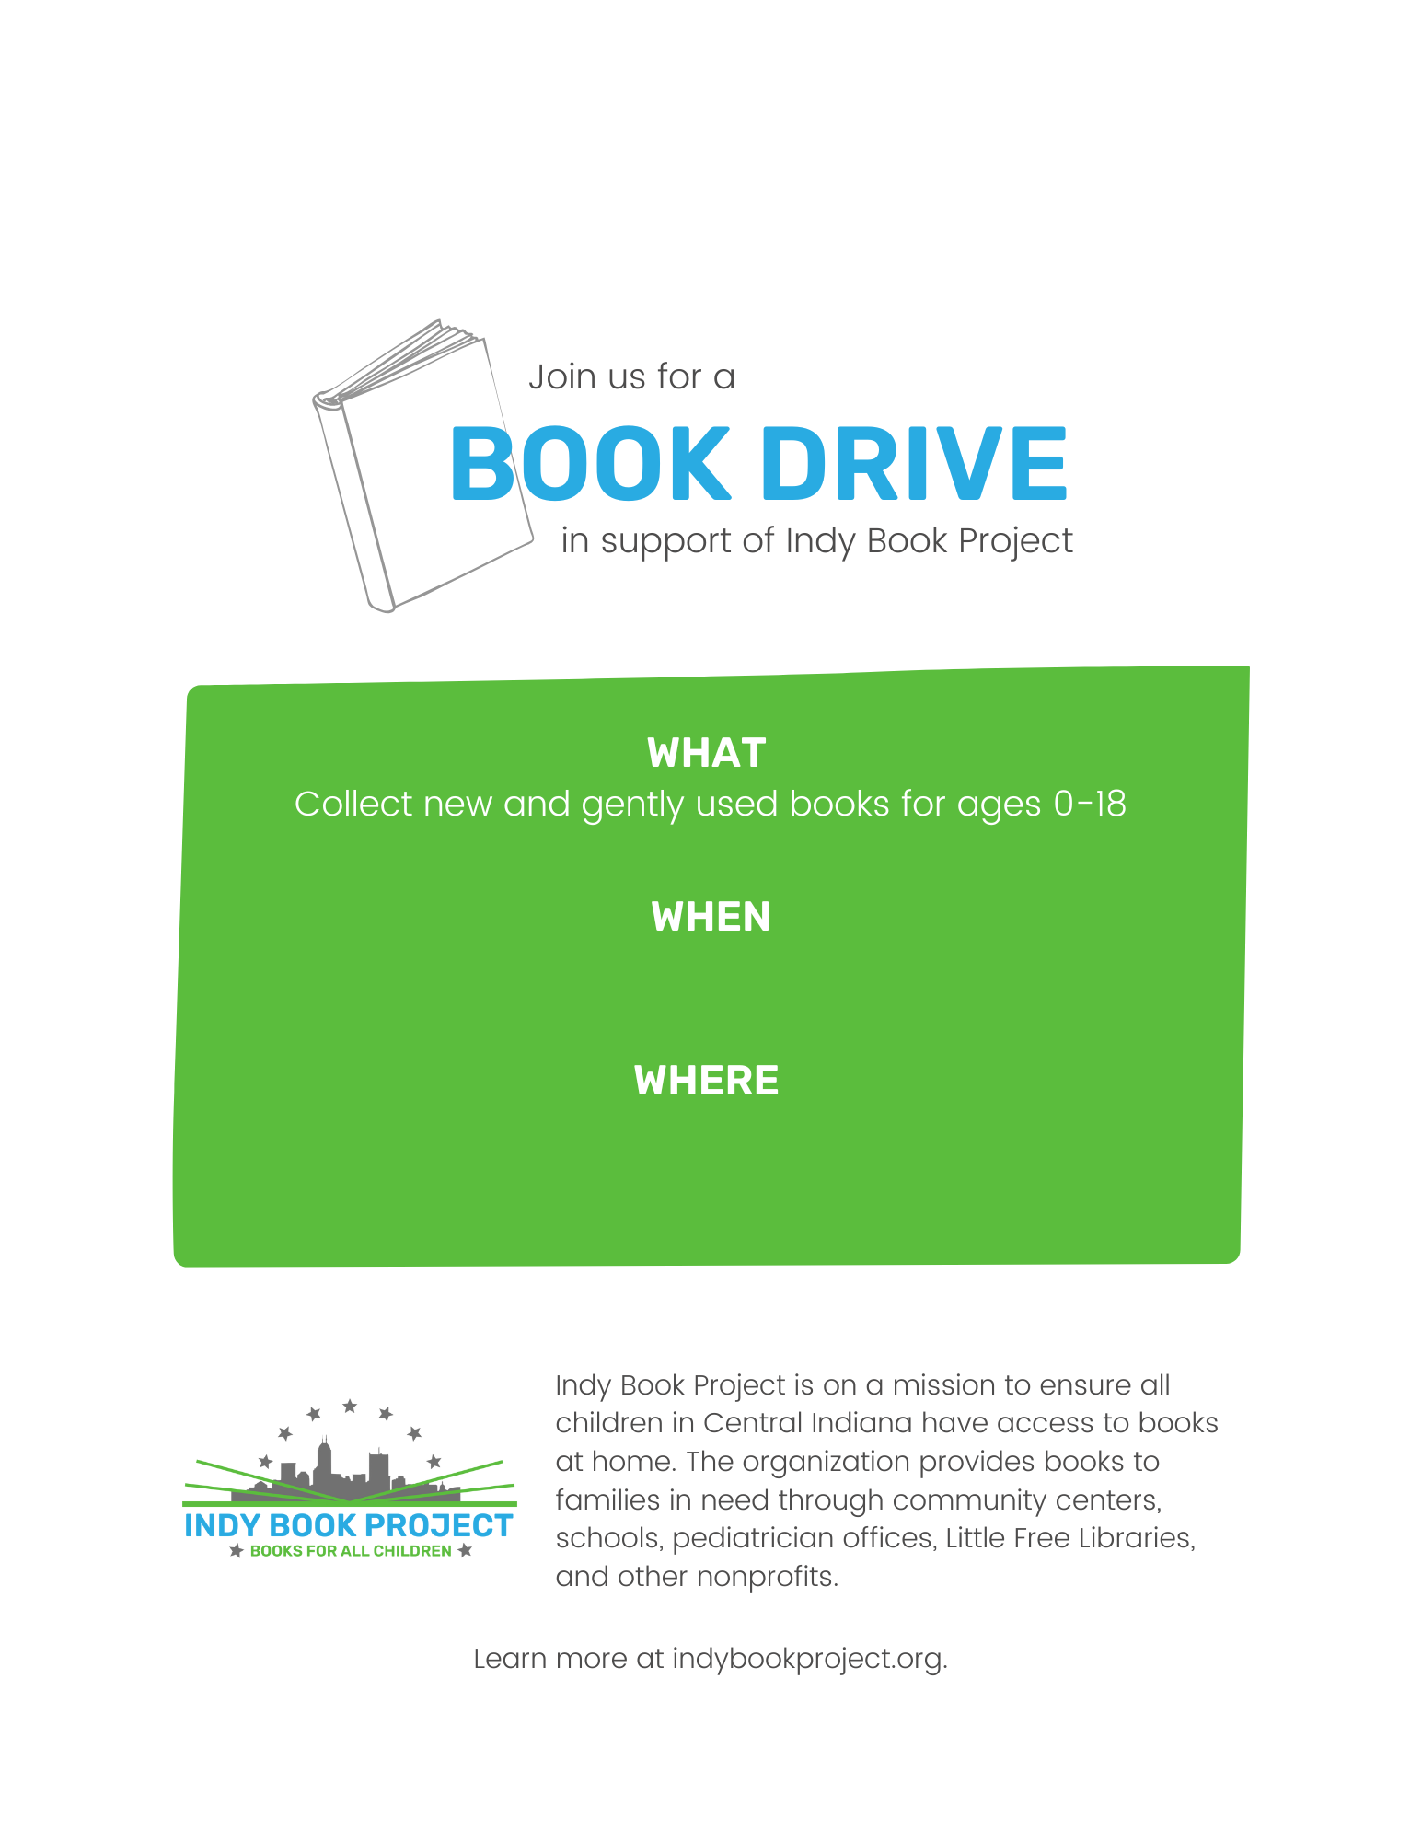
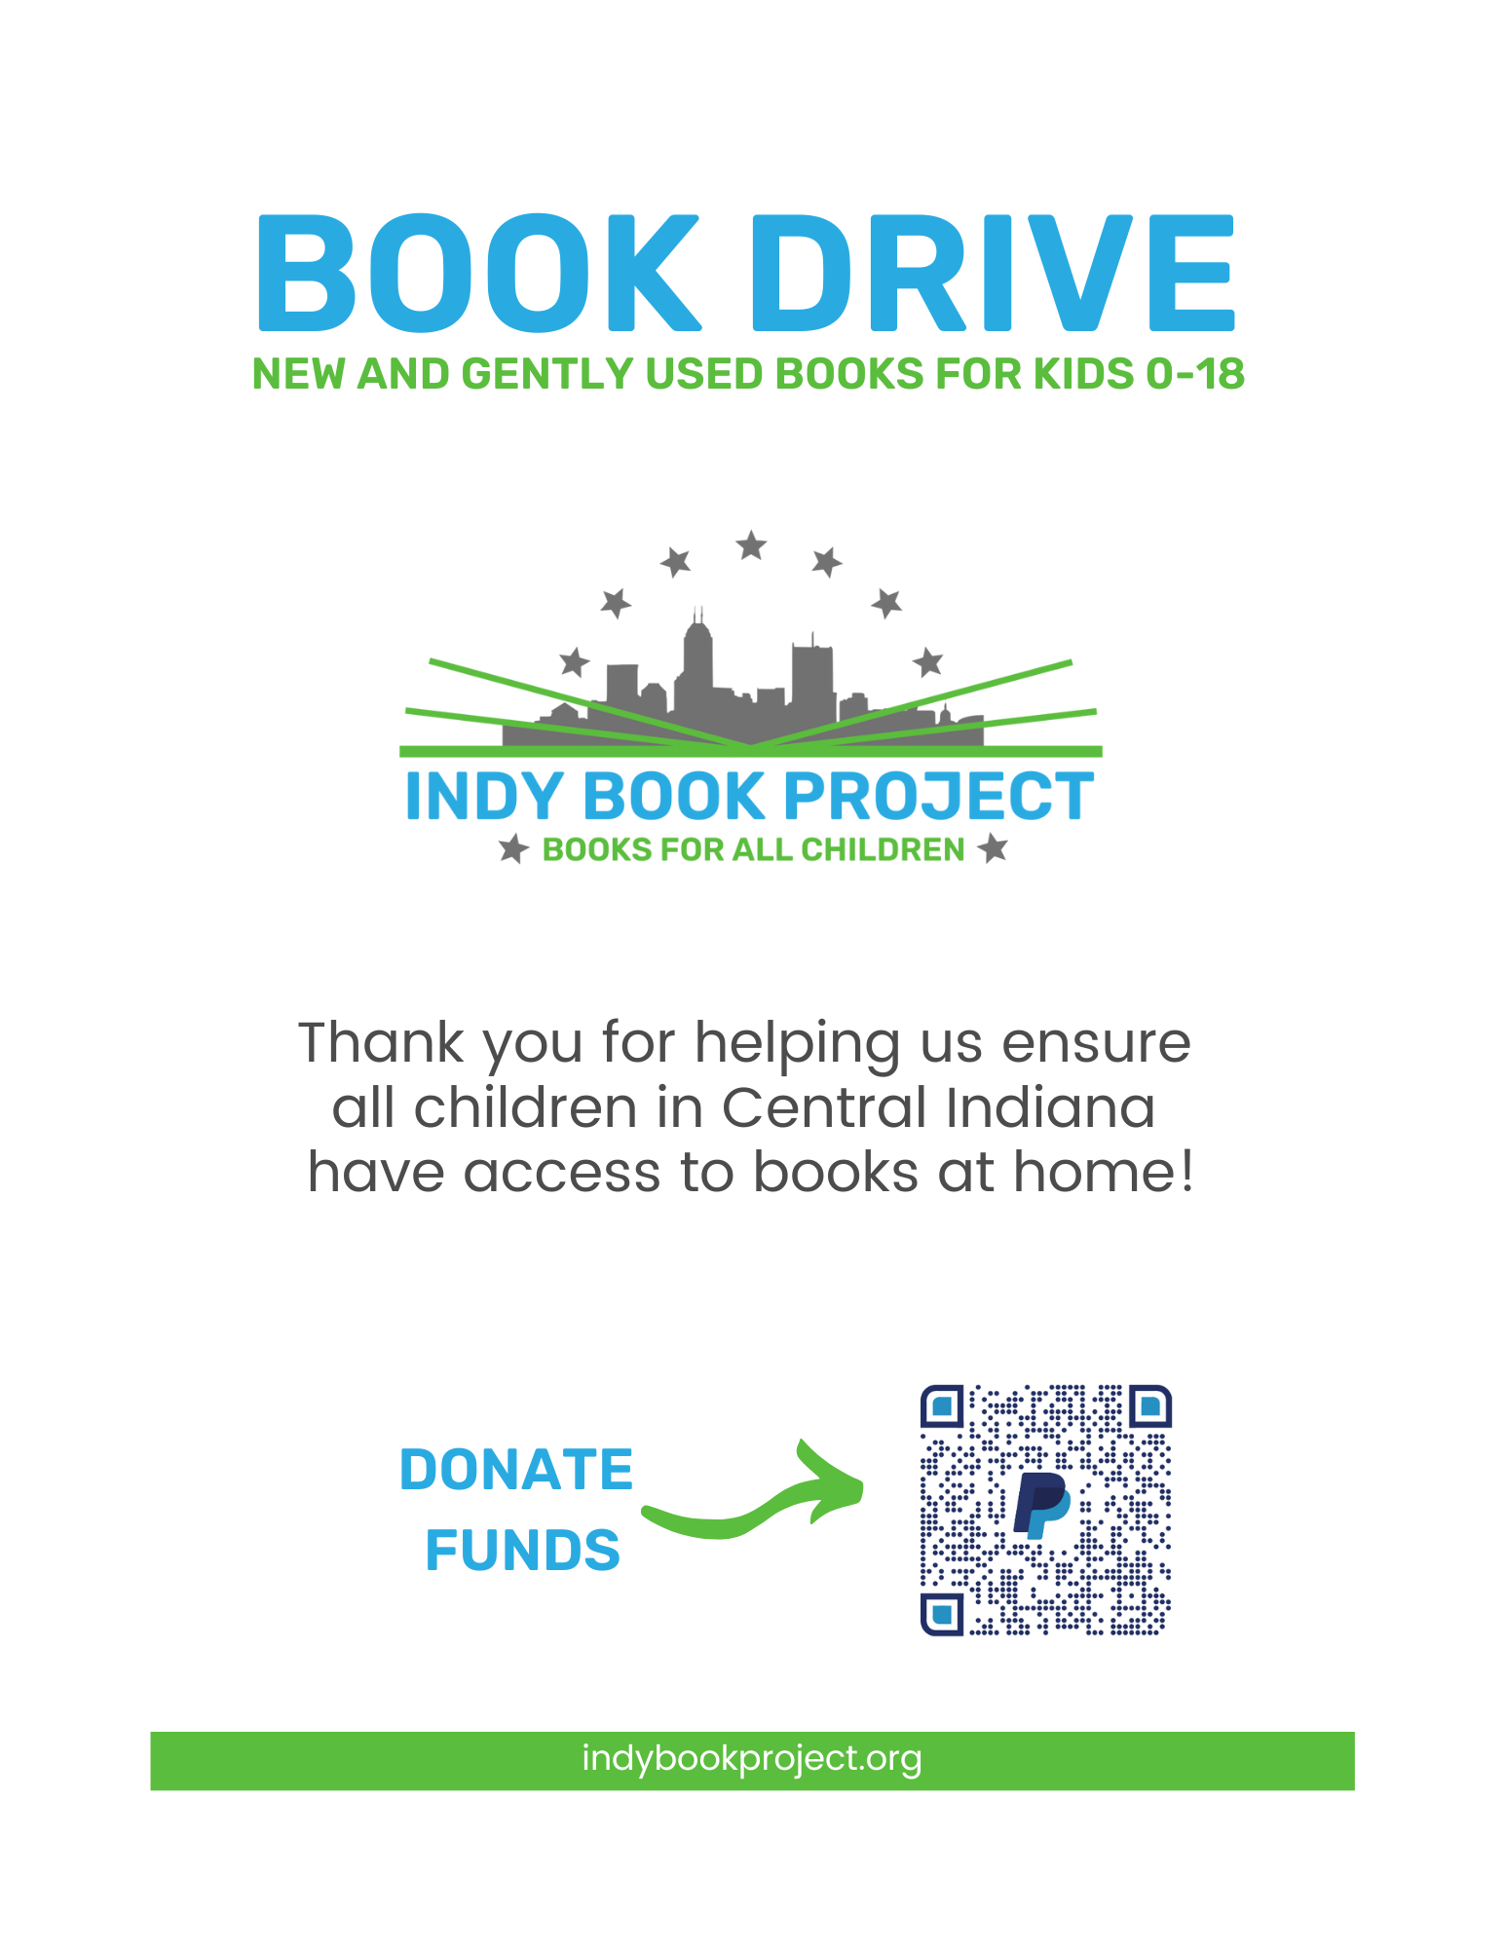

Book Drive Proposal Email

Hi [Name],

I’m reaching out to share an opportunity for giving back to the community. Do you have time in the next week or so to discuss the possibility of hosting a book drive this year at [school, business, location name]?

I’m working with a local, volunteer 501(c)(3) organization called Indy Book Project, which has a mission to ensure all children have access to books at home. This nonprofit collects new or gently used books for kids ages 0-18, sorts them, and distributes them to community centers, schools, doctor’s offices, and other locations that serve youth. Such organizations include Eskenazi Pecar, Crooked Creek Food Pantry, IPS Schools, and Little Free Libraries. To date, Indy Book Project has gifted over 100,000 books to local children.

Several schools and groups in the Indianapolis area have successfully collected thousands of books with one-week drives, and I’m hoping to do the same. I believe this is a fun and productive way to bring people together to support the broader community. I’m willing to lead this effort if you’re willing to support it.

Please let me know if we can meet to discuss further. I’m available [date/time range].

Thank you for your time and consideration. I look forward to speaking with you soon.

Kind Regards,

[Name]
​

Book Drive Proposal Checklist

Location:
- Will the whole school, a division, or a different group participate?

Resources:
- Whose help is needed?

Date:
- What are the start and end dates?
- Should the drive be scheduled around a school event or holiday?

Collection:
- What are the logistics? When, where, and how will books be collected?
- When and how will boxes be secured before the drive, if needed?

Incentives:
- Should there be a contest with prizes?
- Should the contest be by grade, classroom, division, or other?
- Should we track quantity, participation, against a target, or other?
- Who will track donations and how?

Promotion:
- Should we put flyers on doors, in bookbags, in folders, or other?
- Can we post online via newsletter, calendar, social media, or other?
- Should emails be sent from school, principal, director, teacher, or other?
- Is there a community meeting or event we can announce the drive at?

Delivery:
- Should the books be dropped off or picked up?
- What is the delivery date?
- Would we want to host a sorting event before delivery?

Book Drive Write-Up

[Winter/Spring/Summer/Fall] Cleaning? Donate Gently Used Books!

Do you have children’s books you no longer use? Are you looking to clear out some space in your home? Consider donating to the [School/Business/Group Name] Book Drive that will take place [dates]. Drop off books in the collection bin located [location details].

This drive is in partnership with Indy Book Project and is aimed at getting books into the hands of children who don’t have easy access to their own reading materials. Indy Book Project collects new and gently used children’s books that they then give to community centers, schools, and other locations that serve local youth. They seek new and gently used books for ages 0-18. They do not accept magazines.

If you have any questions about the drive, please contact [Contact Name and email/phone].

